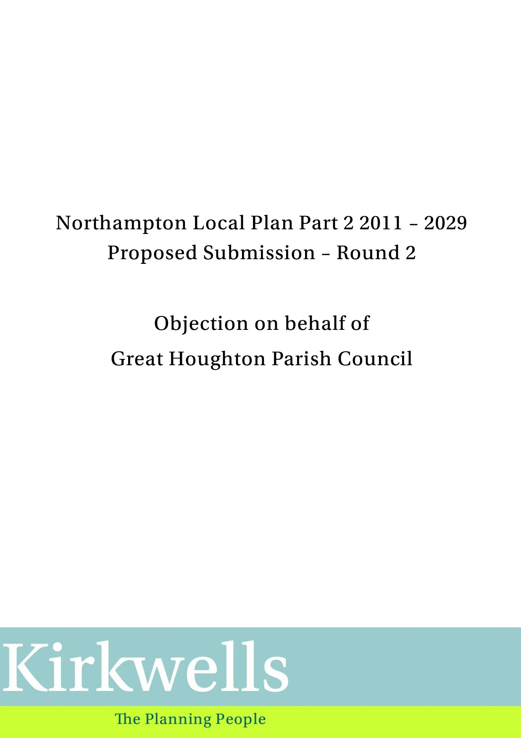

Introduction
- This representation to the Northampton Local Plan Part 2 2011 – 2029 Proposed Submission – Round 2 (henceforward Local Plan Part 2) is made on behalf of Great Houghton Parish Council.

- The Parish Council representation sets out below how the allocation of The Green at Great Houghton fails to meet the NPPF’s tests of soundness. This representation shows that the allocation of this site is not positively prepared, justified, effective or consistent with national planning policy.

Positively prepared

- To be positively prepared Local Plan Part 2 should provide “a strategy which, as a minimum, seeks to meet the area’s objectively assessed needs¹⁹; and is informed by agreements with other authorities, so that unmet need from neighbouring areas is accommodated where it is practical to do so and is consistent with achieving sustainable development.” (NPPF, paragraph 35).

- The Local Part 2 strategy is flawed, it goes beyond meeting Northampton’s minimum objectively assessed need (OAN) that is set out in the West Northamptonshire Joint Core Strategy (WNJCS). The WNJCS sets a minimum OAN of 18,870, 2011-2029 (WNJCS Policy S3).

- The Local Plan Part 2 allocates land for 3,807 new dwellings (Table 6, Local Plan Part 2), of which 3,394 are expected to be delivered over the plan period 2011-2029, 17.98% more than is required. This includes The Green, Great Houghton.

- This significant oversupply is unnecessary, being unwarranted, not achievable and not sustainable.

- Local Plan Part 2 and the Council’s supporting documents (Housing Technical Paper https://www.northampton.gov.uk/downloads/file/12104/01-housing-technical-paper; and 5 year Housing Land Supply https://www.northampton.gov.uk/downloads/file/12108/04-5yhls-nbc-2019) show a consistent and significant under-performance in delivering the WNJCS minimum target:

“By 1st April 2019, 5,727 dwellings had been delivered, against a JCS requirement to allocate sufficient sites (allowing for windfall) to accommodate 8,157 new dwellings in Northampton by that time. The number of dwellings delivered by 1st April 2019 falls some 2,430 units short of the delivery trajectory set out in the JCS (see Table 6).” (Local Plan Part 2, paragraph 7.1).

- The Council acknowledge that the aspirational 1,000+ new dwellings expected per annum 2014/15 to 2023/24 has “not materialised” (Local Plan Part 2, paragraph 7.2) and that “delivery of new dwellings at the SUEs has been relatively slow” (op. cit.). These points are illustrated in Table 6 and Graph 1 of the Local Plan Part 2.

- The Council acknowledge that not all of the dwellings to be delivered by the SUEs, will be completed before 1st April 2029.

- The Council’s answer to this persistent under-delivery against the WNJCS target is to allocate even more land. The Council’s original housing trajectory was informed by the economic conditions and intelligence at the time it was being progressed. On all reasonable assumptions those conditions and intelligence are now out of date and no longer reliable.

- Based on the foregoing, the Council’s strategy is flawed, being unnecessary and unwarranted. Unnecessary because there is already sufficient land to meet the WNJCS target; unwarranted because the evidence in Northampton over the past shows that the housing trajectory has been over-stated, and overly-aspirational when compared with economic intelligence. This is particularly the case with a larger site, such as The Green, Great Houghton. The Council’s strategy fails to learn from past mistakes, that larger sites (The Green is comparable in size to the smaller Sustainable Urban Extensions) are more difficult to deliver and require considerable new infrastructure. The Green at Great Houghton, by adding to the housing land supply, will create further over-supply, competing with the other larger sites for new households and infrastructure resources. The 2019 Infrastructure Delivery Plan set out that:

“5.2 Funding strategic infrastructure remains a challenge. Strategic infrastructure can be delivered in a number of ways, including public sector investment (such as Central Government funding for major projects) private sector development (including developer contributions to public sector projects) and the business plans of statutory undertakers. As Government funding continues to be limited and developer contributions are still often affected by viability issues, at least in the short term, funding strategic infrastructure will remain challenging. Nevertheless, evidence shows that Northamptonshire has experienced a steady recovery following the economic downturn of 2008 and despite the economic uncertainty following the Brexit vote is well placed to thrive.”

- Add additional large land allocations requiring additional resources, and Covid-19, and this position only gets worse.

- Having said this the Parish Council do acknowledge that given there is such a clear distinction between performance on larger sites (poorer) and smaller sites (better) that Local Plan Part 2 could and should look to offset some of the under-delivery against the WNJCS target by identifying smaller sites.

- However, the identification of an additional larger site at The Green, is at the heart of the Council’s flawed strategy. At a time when economic conditions are weaker and resources constrained the Council should be looking to support development on already identified sites, not by unleashing further supply. With its current allocations Local Plan Part 2 seeks to bring forward an additional supply of land of 17.98% against the WNJCS target. This is unnecessary, the Council are already acknowledging persistent under-delivery; unwarranted in that it is not justified by the evidence; and not achievable.

- The logic is flawed. What other organisation at a time of persistent under-delivery – 2,430 dwellings short of a target of 8,157 (1st April 2019), an under-performance of 29.79% would seek to increase the target by a further 17.98%. This level of over-provision will only lead to further under delivery, sites being allocated unnecessarily and, therefore, not sustainably. A much more measured approach is required, excluding the identification of further large sites and the identification, where possible, of sustainable small and medium sized sites that can be delivered in the short to medium term. In short, the Council are merely repeating past mistakes. On their own evidence larger sites have not achieved what was expected of them. But to make matters worse by allocating almost 25% of the additional housing land at one site The Green. Excluding The Green in favour of smaller sites would still lead to over-provision of 2,594 or 13.75% when compared against WNJCS target.

- On a practical level it is argued that The Green, with the timescales involved, and the need for infrastructure resources will not be in a position to enhance delivery. Indeed, it will increase the target and fail to deliver. Appendix A, page 179 of Local Plan Part 2 assumes The Green will deliver 800 news units 2018/19 to 2028/29. This is not achievable. We are already in the second of those years (by which time, the Council assumes 50 units completed) and there is no prospect of a start on site in the medium term. Allocating land at The Green will not solve the under-delivery against target in Northampton. Indeed, it will make things worse by adding additional competition to the existing pool of large sites for infrastructure and other resources. The Council should address the under-delivery issue by concentrating resources on delivering the existing SUEs and facilitating the development of smaller sites.

Not Justified

- As set out above the Parish Council do not consider Local Plan Part 2 is putting forward “an appropriate strategy, taking into account the reasonable alternatives, and based on proportionate evidence” (NPPF, paragraph 35).

- The continued over-reliance on a further larger site (The Green) and the existence, within Local Plan Part 2 itself, of sufficient smaller sites to increase supply, if not delivery, is a reasonable alternative.

- In addition, development of The Green is not justified for the following detailed reasons.

Traffic

- Northamptonshire County Council in their letter dated 3rd April 2020 concerning Traffic Modelling and Analysis make the following comments on The Green allocation:

“As I have commented previously, the location and topography of site 1098 (The Green, Houghton) suggests that it will connect to The Green. This a minor unclassified road which is likely to require significant upgrading to accommodate development on this scale. While access from The Green is possible to both Newport Pagnell Road and Bedford Road, little traffic is heading to the latter which appears to be the result of the cumulative impacts of all the various developments in that area.

The V/C ratios on the eastern Bedford Road approach to the Barnes Meadow interchange are in the 100-100% range in the AM peak do-minimum scenario (without the plan allocations) and are unchanged in the do-something scenario (with the plan allocations). The traffic flows difference plots show that flows are barely changed, but do indicate additional flow through the Brackmills industrial estate which would appear to be traffic avoiding the Bedford Road.

Combined with knowledge of the existing traffic situation in the area, this would indicate that some significant upgrading of the eastern Bedford Road approach to the Barnes Meadow roundabout will be required, specifically the widening of the river bridge (which being so close to the A45 is a constraint on stacking capacity at the signal stop line).

While this will not be cheap, it should be noted that the design of the bridge does enable relatively easy widening, as this was done on the similar structure west of the A45 some years ago.

It should be noted that there is also a discernible movement off traffic off Newport Pagnell Road which is rat-running through Brackmills to reach the A45 at Brackmills Interchange, but this impact may be mitigated if it is easier for traffic from The Green to exit via Bedford Road.”

- This response fails to take account of any impact on the existing village of Great Houghton. Additional traffic generated by the development will have a severe impact on Great Houghton village.

- The County Council identify The Green – “as a minor unclassified road which is likely to require significant upgrading to accommodate development on this scale”. In reality this is an unlit single track road with passing places and blind bends. At the moment, the edges of the road break down, especially during winter, creating large potholes which need regular repair. There is frequent fly tipping in the passing places. At present this route does not cope with its current traffic usage.

- The Green is bordered by agricultural land and, whilst at a cost, this route could potentially be improved, such an improvement fails to take account of the extra traffic passing along the High Street in the village, a road which cannot be upgraded. Existing problems within the village will only deteriorate further.

- The impact of increased traffic along the village’s main thoroughfare, Great Houghton High Street, and at the junction of this route with the A428 Bedford Road to the north of the village needs to be re-considered.

- Great Houghton High Street (“The High Street”) runs north/south through the village and is single carriageway in both directions. The High Street is narrow, with parked cars at various points, especially where local homes have no off-street car parking. This reduces traffic speeds and creates numerous bottlenecks. Nevertheless, some drivers and cyclists speed, particularly when heading downhill in a northward direction.

- Pedestrians using the length of the High Street have to regularly cross the road as there is pavement on one side only in places. This includes children using school buses from Little Houghton Primary School and Wollaston School and anyone using the Village Hopper bus (they all stop at the White Hart pub).

- National Cycle Route 6 passes up the High Street from the disused railway line at the Glebe and then passes along the Green. It is well used and provides an opportunity to improve health and active lifestyles. However, there is an incompatibility between these aims and the additional traffic created by development at The Green that will use the cycle route, making it significantly less safe for cyclists and deterring users of this mode of travel.

- The High Street is not suitable for HGVs. Formal warning signs have been placed with regard to HGVs entering the village. This does not deter such use and leads to such vehicles mounting footways.

- There are roughly 300 homes in Great Houghton. If 800 new homes are to be built on The Green housing allocation, and assuming a minimum of 2 cars per new dwelling, 1,600 extra vehicles will potentially use The Green. The County Council assumption is that The Green (with significant upgrading) will be used, but that assumption fails to take into account the impact on the High Street, usage and detrimental impact will increase significantly.

- At the north of the village the High Street meets the A428. The A428 has a 60mph speed limit. There have been accidents, including fatalities, at the junction. Villagers must use this junction and turn east to access the local school/Post Office/church which are all in Little Houghton. This manoeuvre can take significant time and is difficult and dangerous to make.

- Additionally, although there are two lanes at the junction, the two-lane stretch is only a few car lengths long. So, once a handful of cars are waiting to turn east, those wishing to turn west and head into Northampton cannot get past them to access the west bound lane and a queue forms up through the village. Given the wait time to turn, the queue moves slowly.

- This effect is exacerbated when there is any problem on the A45 or the M1 (we also note that in their response dated 3rd November 2017 to the Sites Consultation, Highways England raised their concerns about new site allocations impact on the Strategic Route Network). The Green (see below) is the quickest route from Wootton to the A428 and cars use the High Street and Green as part of a cross country route between the A45/M1 and the A428. The wait time in particular to make the eastbound turn is then extended. Essentially, because of the slow turn, even just a few additional cars result in a significant wait. A queue of cars may also be seen waiting to turn south on the A428 to go south, up the High Street.

- There is no way to widen the High Street, as there are houses on either side of its length. Much of this route is also within the Conservation Area.

- The village and The Green site are poorly served by public transport. The Sustainability Appraisal refers to buses on the A428 Bedford Road. It is difficult to understand how these would be used by residents of The Green. This is some 2km (straight line) distant from The Green site allocation. This is considered beyond reasonable for bus users to consider using. The bus stops on the A428 are already difficult for more nearby residents of Great Houghton village to use, particularly those with mobility problems, being accessed via the High Street, the problems of which have already been highlighted. Access for those going eastbound, or returning from Northampton, would also entail crossing the Bedford Road to gain access to the village/The Green site, there have been two recent fatalities in this area of bus users crossing this road. Bus is not considered an option for The Green site.

Loss of character and setting

- Great Houghton is a village which has grown organically through small developments. The centre of the village is a Conservation Area; this includes the portion of the High Street that would be affected by additional traffic and queueing.

- The development of 800 new dwellings is out of scale with the village and will begin the gradual erosion of the separation of the village from Northampton. The village will lose its separate identity.

- At the moment, leaving the village to the south and travelling towards The Green allocation land, beyond Leys Lane (the entrance to the village hall and playing field), one enters open countryside. This open land is an integral part of the setting of the village and its detachment from other built development. This is noted in the Conservation Area Appraisal “The visual separation between Great Houghton and the built-up area makes a major contribution to the setting and to the character and appearance of the Conservation Area.” (page 16, https://www.northampton.gov.uk/info/200207/building_conservation_and_trees/1629/great_houghton_conservation_area).

- Allocation of this site will also lead to loss of Grade 2 agricultural land and functionally linked habitat for golden plover and lapwing linked to the Special Protection Area.

- On these matters the Council’s own SAMLA concludes:

“Significant negative effect likely on proximity of designated sites/ on avoid loss of greenfield land/ on avoid loss of high quality agricultural land.”

- Rather than deal with these issues now Policy 41 merely says they will be subject to further study and suitable mitigation. Without knowing the impact development of The Green may have the site should not be allocated.

Pressure on local services

- Additional residents will mean greater pressure on services including schools, doctors and dental surgeries etc. In particular, the local primary schools are Wootton, Caroline Chisholm and Preston Hedges, all of which are oversubscribed to the extent that applications are in some cases limited to those living within half a mile. Great Houghton’s local primary school is in Little Houghton. This is a small village school (it currently has just under 100 pupils and is almost full) and would not have the necessary capacity for a development of this size. The development needs to be self-sustaining in this respect as existing resources are insufficient. This is a further drain on already scarce resources.

Effective

- The third test of soundness concerns is the plan effective? This response has already demonstrated that the Local Plan Part 2 strategy is not deliverable over the plan period (see paragraphs 3 to 16 of this response).

Consistent with national policy

- The Green housing land allocation would not enable sustainable development in accordance with the policies of the NPPF.

- Whilst The Green allocation would contribute to the national aim of increasing housing growth, this is unnecessary at this time, on an inappropriate site and comes with significant negative costs – many of which remain to be quantified.

- Paragraph 72 of the NPPF provides specific policy guidance for those seeking to identity large sites:

“72. The supply of large numbers of new homes can often be best achieved through planning for larger scale development, such as new settlements or significant extensions to existing villages and towns, provided they are well located and designed, and supported by the necessary infrastructure and facilities. Working with the support of their communities, and with other authorities if appropriate, strategic policy-making authorities should identify suitable locations for such development where this can help to meet identified needs in a sustainable way. In doing so, they should:

    - consider the opportunities presented by existing or planned investment in infrastructure, the area’s economic potential and the scope for net environmental gains;
    - ensure that their size and location will support a sustainable community, with sufficient access to services and employment opportunities within the development itself (without expecting an unrealistic level of self-containment), or in larger towns to which there is good access;
    - set clear expectations for the quality of the development and how this can be maintained (such as by following Garden City principles), and ensure that a variety of homes to meet the needs of different groups in the community will be provided;
    - make a realistic assessment of likely rates of delivery, given the lead-in times for large scale sites, and identify opportunities for supporting rapid implementation (such as through joint ventures or locally-led development corporations)35; and
    - consider whether it is appropriate to establish Green Belt around or adjoining new developments of significant size.”

- The Green is not well located or well supported by necessary infrastructure or facilities (paragraph 72a). The Green is not included within existing or planned investment for infrastructure – it will bring an additional and competing claim on such resources.

- The Green will not be a sustainable community (paragraph 72b). It will be car dependent with poor access to services, especially for those without access to a private car and limited access to employment opportunities. Neither of these will be available on site. Policy 41 fails to identify how any needed infrastructure improvements will be funded or provided; this is not consistent with paragraph 34 of the NPPF:

“34. Plans should set out the contributions expected from development. This should include setting out the levels and types of affordable housing provision required, along with other infrastructure (such as that needed for education, health, transport, flood and water management, green and digital infrastructure). Such policies should not undermine the deliverability of the plan.”

- By failing to quantify these needs the allocation of The Green undermines the deliverability of the WNJCS and Local Plan Part 2, we note our earlier points, and the Council’s own position, that delivery on large sites is persistently under delivering.

- Policy 41 does set out a set a parameters for the quality of the development (paragraph 72c).

- Policy 41 does not make a realistic assessment of likely rates of delivery (paragraph 72d) nor does it set out any mechanism for how the site can be delivered.

- Paragraph 72d is not considered relevant.

- Paragraph 103 of the NPPF states:

“Significant development should be focused on locations which are or can be made sustainable, through limiting the need to travel and offering a genuine choice of transport modes. This can help to reduce congestion and emissions, and improve air quality and public health.”

- The Green allocation would be significant development and as has been shown elsewhere in this representation, development of this site is not sustainable: it does not limit the need to travel, there is no genuine choice of transport modes; as a result this will lead to increased congestion and have negative impacts on air quality and public health.

Conclusion

- The allocation of land at The Green as has been shown in this representation is unnecessary and not sustainable. The Parish Council seeks the removal of this allocation from Local Plan Part 2.

- If the Borough Council should disagree with this position and proceed with the allocation, the Parish Council will seek the following changes to Local Plan Part 2:

- Allocation of the area shaded green in Figure 20 of Local Plan Part 2 as a green wedge. This will ensure continued separation of the proposed new development from Great Houghton village.
- Quantification of the traffic impact on The High Street, Great Houghton and identification of specific mitigation measures to avoid or mitigate these impacts.
- Surveys should be undertaken before the land is allocated to identify whether the site is used by over-wintering Golden Plover / Lapwing i.e. to be carried out in the winter. If significant numbers of Golden Plover or Lapwing are identified at the site, offsite mitigation required for the loss of habitat should be identified as part of the allocation.

