Great Houghton Parish Council

Chairman: Clerk:

Cllr Bill Garner Mr Mike Billingham

Councillors are summoned to the Extraordinary Meeting of Great Houghton Parish Council to be held on Tuesday 20 July 2021 by way of Zoom Video Conference commencing at 7.30 pm.
Members of the public and press are very welcome to attend.
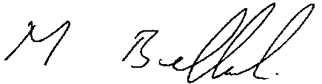

Mike Billingham Clerk Dated 15 July 2021

The business to be transacted is as follows:
039/21. Opening Procedures
- To receive and approve apologies for absence:
- To approve the minutes of the previous Ordinary Council Meeting held on Tuesday 13 July 2021
- To receive declaration of interests related to the business on the agenda
Members are reminded that the disclosure of a Disclosable Pecuniary interest will require that the member withdraws from the meeting room during the transaction of that item of business)
040/21. Public Participation Section

Members of the public are invited to address the council. limited to 15 minutes maximum with individual contributions limited to 3 minutes)
041/21 To consider and approve updated NDP.

Join Zoom Meeting
https://us02web.zoom.us/j/83700352333?pwd=T1A3ZzJSbTRHSzdLeVNVSmJtRVVEUT09

Meeting ID: 837 0035 2333
Passcode: 417333
One tap mobile
+442080806591,,83700352333#,,,,*417333# The United Kingdom
+442080806592,,83700352333#,,,,*417333# The United Kingdom
Dial by your location
+44 208 080 6591 The United Kingdom
+44 208 080 6592 The United Kingdom
+44 330 088 5830 The United Kingdom
+44 131 460 1196 The United Kingdom
+44 203 481 5237 The United Kingdom
+44 203 481 5240 The United Kingdom

