Great Houghton Parish Council

Chair: Clerk:

Councillor Bill Garner Mr Mike Billingham CILCA

The Great Houghton Annual Parish Meeting
Has been convened by Great Houghton Parish Council Chair, Councillor Bill Garner to be held at 7.45 pm on Tuesday 31 May 2022 at
Great Houghton Village Hall, Leys Lane, NN4 0AN.

All members of the parish are invited to attend.
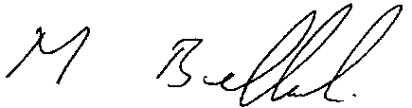

.
Mike Billingham Clerk Dated 24 May 2022

The business to be transacted at the meeting is as follows:-

- Appointment of the Minutes Clerk – Mike Billingham Parish Clerk

- Apologies

- Approval of the minutes of the meeting held on the 25 May 2021.

- Chairman’s report – Cllr Bill Garner

- To receive the reports from Village Organisations:
- GHPFA
- Neighbourhood Warden
- Neighbourhood Watch
- Parish News
- Pocket Park
- Police
- Short Mat Bowls
- WI
- Church

- Questions from the floor

- Chairman’s closing remarks.

