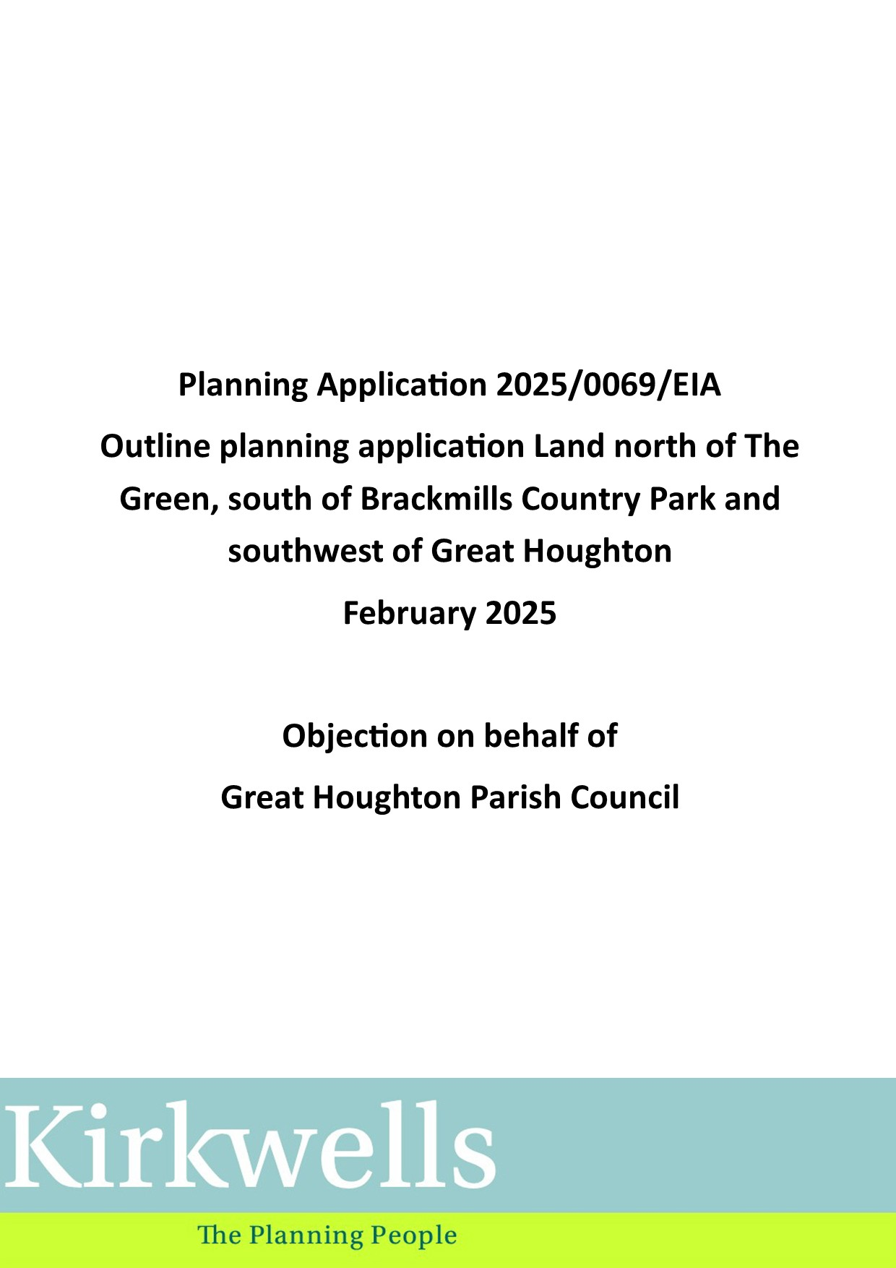
Introduction
- This response to outline planning application 2025/0069/EIA is submitted on behalf of Great Houghton Parish Council (GHPC) by Kirkwells.

- Kirkwells is an independent, chartered town planning consultancy with 15 years’ experience of preparing responses to planning applications and has prepared a number of neighbourhood development plans in the West Northamptonshire area, including the made Great Houghton Neighbourhood Development Plan.

- The planning application is made in outline with all matters reserved for future approval other than access. The description of development is as follows:

“Outline planning application with all matters reserved (except vehicular access) for residential-led (class C3) mixed use development, with commercial uses (use class E(a), E(b) and E(c)), community use (class F.2) and ancillary infrastructure and open space, demolition, and/or refurbishment of existing buildings and together with ancillary works”

4 drawings are submitted for approval comprise as part of the application:

(i) Site Boundary Plan (drawing GTH002-042 Revision D)
(ii) Parameter Plan (drawing GTH002-062 Revision A)
(iii) Building Heights Plan (GTH002-078)
(iv) Proposed Site Access (drawing 33221093-STN-HGN-SW-DR-CH-101)

The Development Plan

- Planning law requires that applications for planning permission be determined in accordance with the development plan, unless material considerations indicate otherwise.

- The development plan for the area comprises the following:

    - West Northamptonshire Joint Core Strategy
    - Northampton Local Plan Part 2
    - Great Houghton Neighbourhood Development Plan
    - Northamptonshire Minerals and Waste Local Plan

The comments in this submission are related to the first 3 of these documents.

- The West Northamptonshire Joint Core Strategy (WNJCS) was adopted in December 2014 and the policies underwent a review in December 2019. The WNJCS sets out an overall vision setting for the area, how places within the area should evolve; strategic objectives for the area focusing on key issues; a strategy for the delivery of these objectives; and an explanation of how the delivery process will be monitored.

- Also impacting on the neighbourhood area and included as a policy of the WNJCS is the Northampton Related Development Area (NRDA). The WNJCS identifies the NRDA to meet the longstanding issue that Northampton is unable to meet its own housing needs: the WNJCS, therefore, identifies a series of Sustainable Urban Extensions (SUE). One of these SUEs is Northampton South of Brackmills where Policy N6 of the WNJCS makes provision for in the region of 1,300 dwellings, a primary school, and a local centre (Figure 1).

Figure 1. Northampton South of Brackmills Sustainable Urban Extension
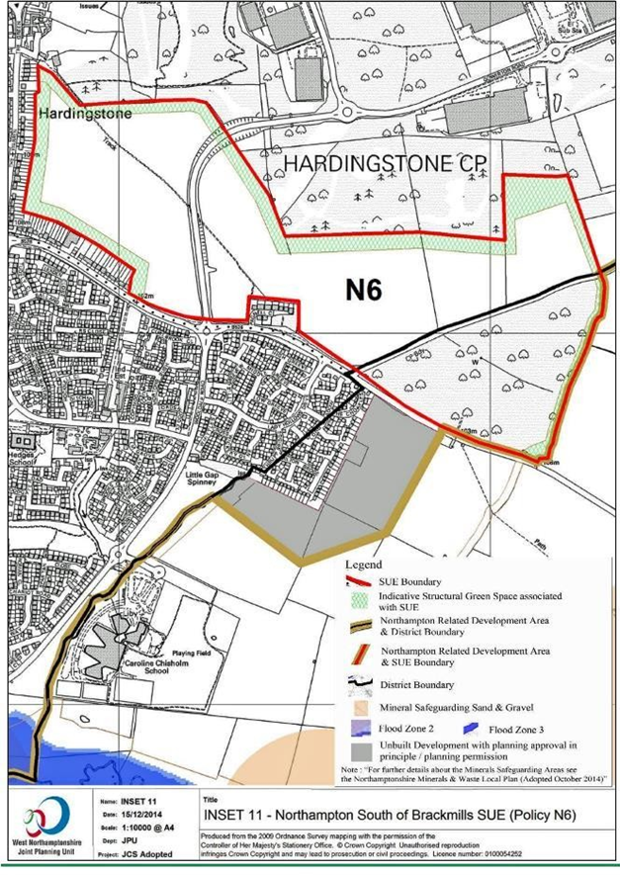
(Source: WNJCS)

Northampton Local Plan Part 2 (NLPP2)

- The NLPP2 was adopted in March 2023. As well as the plan-wide policies that operate throughout the area that may be relevant to this planning application, NLPP2 also includes a site-specific policy for the application site – Policy A3 The Green, Great Houghton. The application site is contiguous with the NLPP2 allocation.

- Policy A3 sets 13 criteria for development at The Green to meet. Those considered relevant to this planning application being set out below with commentary on how these matters are treated in the outline application:

“iv. Proposals should include suitable measures to mitigate the impact of additional traffic generated by the development. The principal access to the site should be from The Green west of Saucebridge Farm, west of the junction of The Green with the unnamed road which leads south at this point, and the development should seek to minimise additional traffic eastwards from this point towards Great Houghton village and the Bedford Road. The intention should be to reduce the potential for traffic use to use The Green to the east or routes through the allocation to travel between the Newport Pagnell Road and the Bedford Road or vice versa.

The parameters plan (GTH002-062 Revision A) and the site access plan (33221093-STN-HGN-SW-DR-CH-101) show the primary vehicle site access to be in the location defined by LPP2.

The site access plan also shows a section of The Green beyond the site access will be subject of a Traffic Regulation Order (TRO) to close it for traffic use and dedicate this to active travel (walking and cycling) only. To prevent visibility of this active travel route and limit anti-social access a landscaping mound and treatment will be introduced.

Given the recent Transport Study commissioned by the Parish Council and submitted alongside this statement (see Appendix 1) it is crucial that this point is addressed along with the advice from WNC to the Developer’s Agent, (David Lock Associates) that they would need to meet the evidence contained within the Transport Study.

xi. A suitable Alternative Natural Greenspace (SANG) will be secured.

The SANG is shown in the same location as the SANG in the NLPP2 (Figure 20). None of the SANG is proposed off-site.

xii. Proposals must be informed by a masterplan for the whole allocation which will be expected to:

a. Take into consideration the surrounding townscape character and remain sensitive to the existing small-scale residential development within Great Houghton to the east and Hardingstone to the west.

The Building Heights Plan (GTH002-078) shows building height will be at 2 storeys on the eastern sections of the site.

c. Manage and control vehicular access to and from the site to the northern / eastern section of The Green near to the village of Great Houghton and minimise traffic arising from the development passing through Great Houghton.

The site access plan shows a section of The Green beyond the site access will be subject of a Traffic Regulation Order (TRO) to close it for traffic use and dedicate this to active travel (walking and cycling) only. To prevent visibility of this active travel route and limit anti-social access a landscaping mound and treatment will be introduced.

d. Connect the site to nearby Brackmills Country Park and surrounding areas including pedestrian and cycling provision to secure connectivity and permeability within the site, to the employment area to the north, the proposed residential areas to the west along The Green and towards Great Houghton as shown on Figure 20

The Parameters plan shows various indicative walking and cycling access points.

e. Provide a SANG within the area identified in Figure 20 which provides the following:

i. Protection, enhancement and / or creation of habitats in line with other policies of this plan
ii. Accessibility for residents’ recreation including an off-lead dog walking area.
iii. A circular walking route around the SANG and eastern development area.
iv. A clear separation between the developed site and the village of Great Houghton in order to protect its setting and the heritage assets of the village.
v. Formal and informal open space
vi. A SANG car park.
vii. If any part of the SANG is proposed off-site, the SANG will need to be adjoining the site.
The parameters plan whilst not strictly a masterplan, shows the following:
- Retained existing vegetation.
- Ecological enhancement of the SANG.
- Areas of natural semi-natural open space
- Park/garden areas
- Structural planting
- Indicative Bat Ecology Corridor
- Indicative allotment and community garden locations
- Separation of the application site and Great Houghton village.
- Active travel routes and indicative walking/cycling access points.
- Indicative SANG car park.
It is considered that based on the Parameters Plan that worked up in more detail as part of a reserved matters planning application these measures would substantially meet criterion e i to vii.
xiii. Ensure built development (other than as may relate to recreation and SANG functions) only takes place outside the SANG, the broad location of which is defined in Figure 20.
Built development as shown on the Parameters Plan is outside the SANG.

Great Houghton Neighbourhood Development Plan (GHNDP)

- The GHNDP was made in May 2022. The GHNDP has been prepared to help shape future development in the parish. It seeks to further build on and to strengthen the Great Houghton Design Statement (GHDS) which was compiled in 2019 following a survey of residents. The GHDS identifies the village’s unique character and the important features stemming from its design and history.

- It should be noted that the western section of the site shown on applicant’s plan drawing GTH002-042 Revision D lies outside the GHNDP boundary and GHNDP policy does not apply to this part of the site.

- Four of the GPNDP’s policies are considered relevant to the outline application:

- Policy GHNDP1 – Protecting Village Character and the Rural Environment
- Policy GHNDP9 - Traffic Management and Transport Improvements

- Policy GHNDP1 – Protecting Village Character and the Rural Environment sets out that development proposals must:

“Provide a clear separation between the development site and Great Houghton by retaining the Green Buffer area (shaded green on the map on Figure 20 of Northampton LPP2, presented on page 21 of the Neighbourhood Plan) for ecological enhancement. As part of an anticipated strategic allocation of the LPP2 the area identified for ecological enhancement is expected to include, to an extent yet unidentified, a Suitable Alternative Natural Greenspace (SANG). This will include walking routes, connections to Great Houghton and neighbouring areas, an off-lead dog walking area and protection, enhancement and creation of habitats in line with other policies of the Northampton LPP2.”

Based on the parameters plan and if included within the reserve matters application these policy requirements would be met.

- The application is considered to meet Policy GHNDP9 - Traffic Management and Transport Improvements by way of minimising impact of traffic on the village and by improving active travel links.
Conclusion
- The planning application is in outline with all matters reserved other than access. The site access shown on (ii) Parameter Plan (drawing GTH002-062 Revision A) and Proposed Site Access (drawing 33221093-STN-HGN-SW-DR-CH-101 is considered to meet development plan policy in NLPP2 Policy A3 and Policy GHNDP1a.

- The Parameter Plan (drawing GTH002-062 Revision A) is also considered to show sufficient information that at reserved matters stage the requirements of Policy A3 iv, xi, xii and xiii can be met.

- Other matters identified in the NLPP2 and GHNDP not addressed in this planning application include:

- Impact on the Special Protection Area (Policy A3 I and ii)
- Air Quality and noise (Policy A3 v)
- Impact on Great Houghton Conservation Area (Policy A3 iii GHNDP Policy 2)
- Archaeology (Policy A3 vi)
- Impact on landscape (Policy A3 vii) Policy GHNDP6)
- Flooding and drainage (Policy A3 vii, viii and ix)
- How traffic will be minimised going east and through Great Houghton (Policy A3 iv and GHNDP Policy 9)
The Parish Council remains concerned that outline planning is being considered with these crucial matters remaining unresolved and needing to be addressed at the later reserved matters stage.
- The Parish Council, in particular, are of the view that the following must be addressed at the outline planning application stage. Without doing this the residents of Great Houghton cannot have any confidence that the site will be developed as envisaged in the development plan.

- Th first of these concerns is the cumulative impact of this and other nearby developments (e.g. Hampton Green), that use the same access roads, unless addressed there will be a serious adverse impact of increased traffic through the village. The Parish Council seeks as a requirement for approval:

- that the Traffic Regulation Order (TRO) to close it for traffic use and dedicate this to active travel (walking and cycling) only.
- That the proposed emergency vehicle access is permanently controlled and managed to prevent inappropriate use and shall not be used for any future non-emergency access.
- That the road from Newport Pagnell Road turning though the village to the Bedford Road turning be restricted so that it cannot be used by HGV vehicles.
- That the applicant and highway authority identify and agree with the Parish Council traffic calming measures to be installed along The Green and The High Street, Great Houghton to mitigate the impact of increased traffic flow arising from the development through the village.
- That the current 60mph speed limit from the Newport Pagnell Road to the village be reduced to 40mph. That the current 30mph speed limit be reduced to 20mph speed limit on roads throughout the village and this restriction to commence further along The Green, beyond the Village sign.

- The Parish Council also remains concerned that drainage issues are not addressed as part of this application. Surface water flooding is an existing problem and the cumulative impact of this and other nearby developments (Hampton Green), will considerably increase the risk of flooding in the village. In particular:

- The council is concerned with the proposed location of ‘catchment’ ponds and ‘connecting’ channels (Surface and Foul Water Drainage Strategy Map) and their close proximity to properties within the village.
- The application should also provide details to establish confidence and certainty where ownership and responsibility for the future management and maintenance of all proposed drainage measures lies.

- Mindful of the serious concerns (listed above) that the overwhelming majority of residents have expressed. The Parish Council objects to this proposed development.

Appendix 1. TTP transport Consulting Report
[submitted as a separate document]
