Great Houghton Parish Council
Minutes of the Ordinary Council Meeting of Great Houghton Parish Council held on Tuesday 17 March 2026 to be held at the Village Hall
commencing at 7.30pm
Members of the public and press are very welcome to attend

In Attendance: Cllr S Williams, Cllr R Shaw, Cllr M Barham, Cllr K Barker, Cllr R Hawkins | Also, in Attendance: M Billingham Clerk, WNC Cllr S Clarke

115/26. Opening Procedures  - To receive and approve apologies for absence:  - To approve the minutes of the Ordinary Parish Council Meeting held on Tuesday 17 February 2026  - To receive declaration of interests related to the business on the agenda. |  |  |  |  | - Apologies were received from Cllr G Glennon, Cllr J Havard, Rev. K Seward  - The minutes of the ordinary council meeting held on Tuesday 17 February 2026 were APPROVED subject to the following correction Minute 107/26 (c) should have said ‘Lunch’ not evening meal.  - There were no declaration of interests relating to the agenda items
Members are reminded that the disclosure of a Disclosable Pecuniary `1 will require that the member withdraws from the meeting room during the transaction of that item of business)
116/26. Public Participation Section |  |  |  |  | There were no members of the public present
Members of the public are invited to address the council. limited to 15 minutes maximum with individual contributions limited to 3 minutes)
117/26. To receive following Reports  - To receive report from West Northamptonshire Councillors  - To receive reports from Police / PLR.  - To receive report from Great Houghton Playing Field Association  - To receive SAS traffic report |  | - WNC Cllr S Clarke provided following report (see appendix A)  - The meeting was referred to the PLR report and crime report. There was no reported crime within the village. Assault Brackmills. Burglary vacant premises The Lakes  - The meeting was referred to the GHPFA report (appendix B). It was noted that both of the fitness ski-steppers were in need of maintenance. One was seized up and the other not working properly.  - The meeting received and noted the SAS traffic report for February 2026. It was further noted that the SAS seemed to now be working OK.
118/26. To receive and approve the Finance & Administration Report  - To approve the Receipts and Payment Accounts to end of Feb 2025  - Confirm payments to be authorised. |  |  |  |  | - The Accounts to the end of February 2026 were APPROVED with a balance of £47,995.50 with no outstanding payments.  - The following payments were AUTHORISED.
  Amazon | card | Subscription | 8.99
  Amazon | Card | road signs | 297.00
  Krystal | T00502 | Web Hosting | 12.00
  Parish Clerk | T00503 | Salary | 249.30
  HMRC | T00504 | PAYE | 249.30
  Parish Online | T00505 | Mapping | 90.00
  Gallagher Insurance | T00506 | Insurance | 3,575.44
  NCALC | T00507 | Training | 55.20
  Parish Clerk | T00508 | Expenses | 38.55
  Tesco | Card | Batteries | 50.00
  TOTAL PAYMENTS FOR MONTH |  |  | 4,625.78
119/26. To receive the Clerks Report.  - Community Speed Watch – future activities  - To consider matters relating to funding and VAT | - The first CSW activity was undertaken on the 5 March. One vehicle exceeding speed limit was recorded. AS the council now retains the equipment it needed to be determined how and when it will be operated. The next dates of operation were determined and will be advised to all CSW volunteers.  - Enquiries from GHPFA on funding and VAT had been responded to. The council would need to consider and determine any requests for grant funding in relationship to the 2026/2027 budget (see accounts)
120/26 To receive and consider Planning Matters  - To consider The Annual Planning Report  - Receive report from PAG.  - To consider and determine preferred Planning Consultant |  |  | - There were no planning applications to be considered other than GHPC response to WNC Local Plan  - There were no matters for the PAG to consider.  - The meeting was referred to communications from the Clerk regarding the need to secure planning consultant and to the proposal received from Nigel Ozier on behalf of Aitchison Raferty Consultants. It was RESOLVED to engage Nigel and to seek a meeting ASAP for advice on WNC Local Plan and other matters.
121/26. To Receive Correspondence & Communications  - Request from WI regarding Celebration participation  - WNC Devolution Strategy |  |  | - The meeting was referred to the request from WI for the council to provide a display at their proposed celebration at the village hall in November. Reference had been made to historic materials from former Cllr Rod Jeakings that had been stored at the hall. It was suggested that the Houghton’s and Brayfield History Society may be able to provide some materials.  - The meeting was referred to WNC Devolution plan previously circulated. Cllr Barham expressed concerns. ACTION Clerk to establish any possible responses from other parish council.
122/26. To receive Report on village maintenance/Highway matters  - Update on Leys Lane, Disused Railway/Cycleway/Footpath.  - To consider arrangements for Litter-Pick |  |  |  | - The clerk had written to planning enforcement regarding the damaged verge in leys lane caused by the permitted rear entry. No response has been received. ACTION Clerk to refer to WNC Cllr S Clarke. No further action has been undertaken regarding disused railway. The meeting was referred to the draft WNC Transport Plan that made vague reference to this.  - The meeting considered arrangement for litter-pick. The clerk confirmed that pick-up sticks, collection bags and Hi-Vis vests were available. ACTION GHPFA and WI to be consulted as to when and where this activity should take place.
123/26. To consider environmental & Biodiversity Matters  - Can Champion - Health & Wellbeing – Wellbeing Plan  - Community Resilience Project  - Local Nature Recovery Strategy  - Women’s Charter |  | - Cllr Hawkins provided update on Wellbeing plan. Proposed that draft to be circulated ready for proposed coffee morning meeting on the 10 April. It was further proposed that a jointly constructed survey form be drafted for production and distribution by the council.  - It was confirmed that John Adams contact details had been forwarded to WNC Emergency Planning. Unfortunately, no second volunteer warden had yet been secured.  - The proposed meeting with organisers of LNRS has been postponed to the April coffee morning due to unavailability of councillor.  - Cllr Hawkins referred the meeting to the WNC Women’s Charter. It was RESOLVED that the council sign up to this charter. ACTION Clerk to process application.
124/26. To consider the monthly public messages |  |  |  |  | - The Council wished everyone a Happy and Peaceful Easter  - The council would refer residents’ attention to the proposed WNC Devolution Document available on our website at: www.greathoughton-pc.gov.uk

Appendix A – WNC Cllr Clarke Report
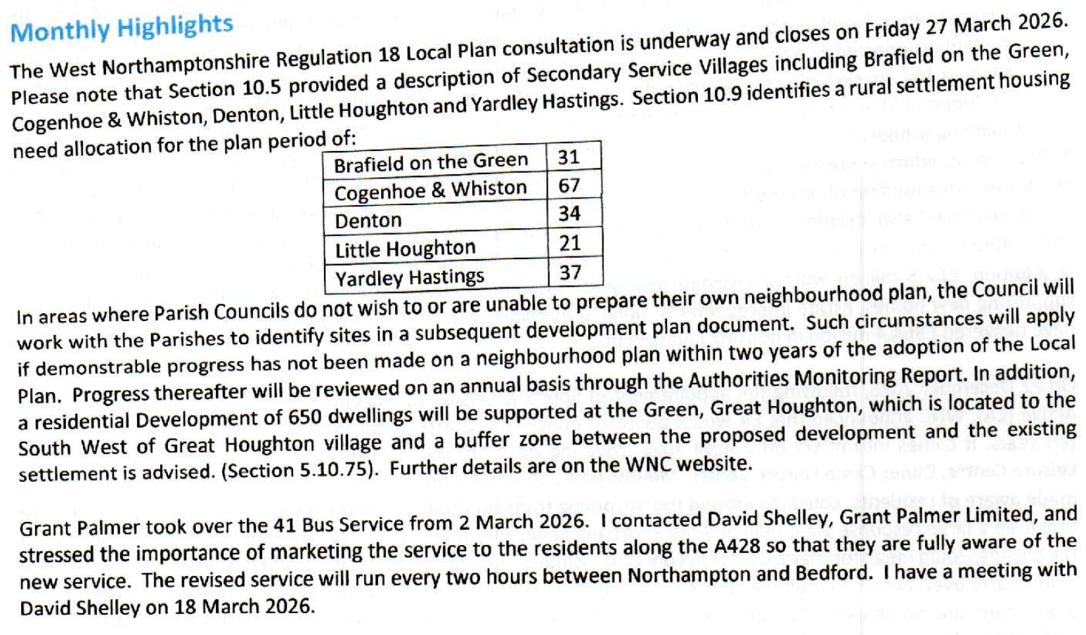

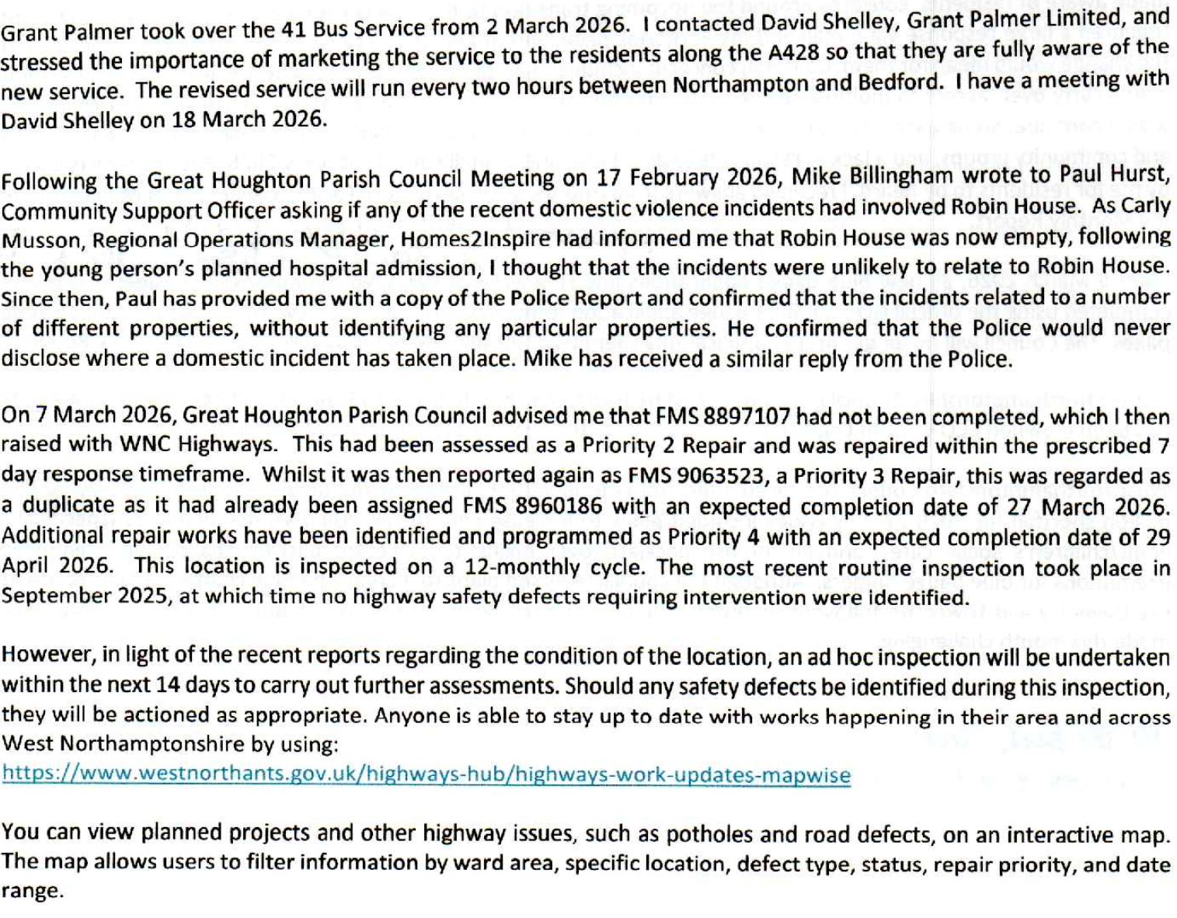

Appendix B – GHPFA Report

1. Finances still strong with £75k+ being held in all accounts.
2. John Adams to call meeting of sub group to discuss and activate repair and maintenance of the hall and playing field as well as exercise equipment and playground equipment. Also to discuss and activate internal external decoration of the hall.
3.Ceroc a regular Sunday user of the hall had a problem with the lack of cleaning of the hall following a previous party. Sue Stevens had to clean the hall with very limited goods as the cleaning cupboard was empty. Thanks given to Sue and arrangements made for the cupboard to be stocked at all times as well as all users to leave the hall in a clean condition.
4.Both rope climbs in the playground area need repairs and this is to be done. i.e.. to install ground mesh to stop the ground area being excessively muddy.
5.The cricket club needs to replace the current artificial surface on the cricket square.Cost of £4k to£6k probable.
6.Also football pitches need treatment to stop excess mud etc. at cost of £720.
7.In relation to works such as those mentioned Peter Hawkins to talk to Parish Clerk to see if the Parish Council could order and pay for such works and re-claim the VAT.The GHPFA would then reimburse the net amount to the Parish Council. Also to discuss if the possibility of financial help could be given by the Parish council if agreed to by Councillors.ks
8.Peter Hawkins to talk to Houghton Hawks to see how much they would sell their mobile floodlighting to th GHPFA for?
9 The WI is celebrating its centenary in Nov.this year and their theme will be the history of our village.their hope is that both the Parish Council and The GHPFA could help with displays or similar in the hall especially on coffee mornings etc.
10. The WNC wellbeing initiative includes Rosemary Shaw and the WI as well as the church. I believe that a meeting is being arranged for the WNC and our own parties to follow this through.

