GREAT HOUGHTON PARISH COUNCIL
Minutes of the Ordinary Council Meeting of Great Houghton Parish Council on Tuesday 21 April 2026 to be held at the Village Hall commencing at 7.30pm.

In Attendance: Cllr R Shaw, Cllr M Barham, Cllr K Barker, Cllr G Glennon, Cllr R Hawkins, Cllr J Havard | Also in Attendance: M Billingham Clerk, WNC Cllr S Clarke

125/26. Opening Procedures  - To receive and approve apologies for absence:  - To approve the minutes of the Ordinary Parish Council Meeting held on Tuesday 17 March 2026  - To receive declaration of interests related to the business on the agenda. |  |  |  |  |  |  |  |  | - Apologies were received from Cllr S Williams.  - The minutes of the ordinary council meeting held on Tuesday 17 March 2026 were APPROVED.  - There were no declaration of interests relating to agenda items.
Members are reminded that the disclosure of a Disclosable Pecuniary `1 will require that the member withdraws from the meeting room during the transaction of that item of business)
126/26. Public Participation Section |  |  |  |  |  | There were no members of the public present
Members of the public are invited to address the council. limited to 15 minutes maximum with individual contributions limited to 3 minutes)
127/26. To receive following Reports  - To receive report from West Northamptonshire Councillors  - To receive reports from Police / PLR.  - To receive report from Great Houghton Playing Field Association  - To receive SAS traffic report  - To receive CAN Champion report |  | - Cllr Clerk provided following report: Details on Leys Lane rear access not planning matter. 41 bus service no subsidy. 4.95% council rate increase £69 garden service. Funding for transport groups. Community transport vital. Seeking to deal with potholes being reported faster than can be repaired. £15.3 Millin Gov funding being provided (see Appendix A)  - The Police Crime Report for March recorded 1 x Domestic Violence in the village and an affray and two business burglaries at Bedford Rd/ The Lakes.  - The meeting was referred to the GHPFA report from Cllr Barham previously circulated. (see Appendix B). The matter of the insurance arrangement between GHPC & GHPFA was raised. The clerk reminded the meeting of the legal advice given to the council regarding the process and procedure adopted at the renewal of the lease in 2021. The landlord being responsible for renewing the policy and the tenant being required to pay the insurance ‘rent’. The clerk had provided GHPFA with a copy of the policy and the amount to be paid back to the council. ACTION Clerk to arrange meeting with GHPC & GHPFA representatives to clarify.  - The meeting received and noted the SAS traffic report for March previously circulated. Over 1.200 extra vehicles compared to previous month. (see Appendix C)  - Cllr Hawkins reported about Land for Community Garden use. It was noted that currently the council does not own any available land for such a project, but it may be that some land could be utilised on the proposed SANG if the planned development of The Green is approved. Suggested that The Great Collaboration may be something to consider in the future.
128/26. To receive and approve the Finance & Administration Report  - To approve the Receipts and Payment Accounts to end of March and end of financial year 1025/2026  - Confirm payments to be authorised.  - To receive and note Internal Control Report  - To consider matter of WNC Special Expenses (Cllr Hawkins) |  |  | - The accounts to the end of march, being the end of the financial year were APPROVED with a closing balance of £42,478.35 and no outstanding payments.  - The following payments were AUTHORISED.  - The Internal Control Report was received and noted. (see Appendix D)  - Cllr Hawkins queried WNC Special Expenses. Explanation provided by WNC Cllr Clarke and parish clerk.
  Amazon | Card | 30 mph signs | 92.37
  Aitchison Rafferty | T00509 | Planning | 1176.00
  Post Office | Card | Stamps | 13.92
  Amazon | Card | 30mph signs | 119.54
  Parish Clerk | T00510 | Salary | 314.40
  HMRC | T00511 | PAYE | 184.20
  Rogers Quickprint | T00512 | Parish News | 297.00
  HGM | T00513 | Maintenance (1094) | 300.00
  NCALC | T00514 | Membership | 800.00
  S Barham | T00515 | Flower Bed | 23.09
  CTL Services | T00516 | Light Kiosk | 185.00
  HGM | T00517 | Maintenance (1078) | 300.00
  Parish Clerk | T00518 | Expenses | 49.17
   |  |  | 3854.69
129/26. To receive the Clerks Report.  - Update Community Speed Watch  - Update on responses received regarding WNC Devolution Plan  - To consider date and agenda items for Annual Parish Meeting |  |  |  |  |  | - More volunteers have joined the group. Have held a further two operations but no one caught speeding. ACTION Clerk to enquire if able to obtain further set of equipment.  - Not much response from other councils so far, waiting for further details and consideration.  - It was RESOLVED to hold the Annual Parish Meeting together with the Annual Parish Council Meeting on Tuesday 19 May 2026 from 7pm.
130/26 To receive and consider Planning Matters  - To consider The Annual Planning Report  - Receive report from PAG.  - To formerly approve response to WNC Local Plan  - To consider review of Neighbourhood Development Plan |  |  |  |  | - There were no applications to consider. The Clerk referred the meeting to his previous email advising that he had not received any consultation relating to properties in The High Street or The Green  - There was nothing for the PAG to consider.  - The response to the new WNC Local Plan produced by the planning consultant was APPROVED.  - The meeting was advised that the Great Houghton Neighbourhood Development Plan, first approved in 2020, should be considered for review in relationship to national and local panning regulations. ACTION Clerk to enquire with planning consultant on likely requirement and cost.
131/26. To Receive Correspondence & Communications  - Comments from Flood Warden regarding drainage ditch rear of Lime Farm Way properties  - Notification of External & Internal Auditors for 2025/2026 Review |  |  |  |  |  |  | - The clerk advised the meeting of comments received from the Flood Warden relating to the flooding issues with a part of the playing field. There is a requirement to ensure that drainage ditches are kept clear. GHPFA are currently looking into drainage issues.  - The meeting was advised that PKF Littlejohn and Tina Charteress have again been appointed as External and Internal Auditors for 2025/2026
132/26. To receive Report on village maintenance/Highway matters  - Update on Leys Lane, Disused Railway/Cycleway/Footpath.  - Update on arrangements for Litter-Pick. |  |  |  |  |  |  |  | - There was no further update on these matters, other than report from WNC Cllr Clarke (above)  - The matter of an organised litter-pick was still to be discussed with WI.
133/26. To consider environmental & Biodiversity Matters  - Health & Wellbeing – To consider draft Wellbeing Plan  - Community Resilience Project – To consider Community Survey  - Local Nature Recovery Strategy |  |  |  | - The meeting considered the draft Wellbeing Plan which, following some proposed changes was APPROVED.  - The meeting was referred to draft Community Survey which, following some proposed changes was APPROVED. ACTION Cllr Hawkins will seek response from other organisations/partners before compiling final copy. ACTION Clerk will arrange the production and distribution of the jointly approved final copy and number required determined.  - The meeting was advised that GHPFA has responded to the strategy consultation which may provide future benefit
134/26. To consider the monthly public messages | - Northamptonshire Care Services Directory can be accessed at: https://www.carechoices.co.uk/publication/northamptonshire-care-services-directory/  - Online safety course preventing scamming can be accessed at:  https://s-url.co/LCMtAA  - Please be mindful of neighbours regarding noise from garden activities.  - Please clean up after your dog
Meeting Closed at 9.30pm

Signature……………………………………….. Dated………………………………………….
Appendix A - WNC Cllr Clarke Report
On 18 March 2026, I met with David Shelley of Grant Palmer to discuss the 41 Bus Service, which currently operates without subsidy. Issues raised included departure times, limited evening services, and implications for onward connections. No timetable changes are planned at present; however, service frequency may be reviewed subject to demand or additional funding. Grant Palmer will continue local marketing and explore coordination with community transport providers, including the Cogenhoe Village Hopper. The enforcement case relating to Leys Lane, Great Houghton is now closed. Planning application 2025/0819/FULL approved a vehicular access using a gravel strip onto Leys Lane, resolving the breach raised by Great Houghton Parish Council. Permission was granted on 19 June 2025, and the Planning Officer’s report is available on the Planning Register. I raised several queries with Nathan Lowde, Team Leader (Development Management), and his responses are summarised separately. Updates on the Green Hill Solar Farm and the transfer of Northampton Partnership Homes back inhouse are included in my Monthly Report. WNC has approved a £464.3 million balanced budget for 2026/27, including a 4.95% council tax increase and £29 million in savings to address service pressures. The budget includes £163 million in capital investment over five years and revised fees, such as an increase in garden waste charges to £69. Temporary emergency support for residents reliant on heating oil was available until 31 March 2026, ahead of the launch of the new Crisis & Resilience Fund (CRF) on 1 April 2026. The CRF replaces the Household Support Fund and Discretionary Housing Payments, with a focus on longer-term resilience. WNC’s provisional allocation is £4.65 million per year until March 2029. Following the Extraordinary Council meeting on devolution held on 13 March 2026, West and North Northamptonshire Councils jointly submitted an Expression of Interest to become a Foundation Strategic Authority on 20 March 2026. WNC has announced a £172,000 Community Transport Grant Fund for 2026/27. Parish councils and community groups can apply to support transport provision in areas with limited or no bus services. The application deadline is 10:00am on 24 April 2026
I remain disappointed by WNC’s response to the demise of the Ability Service. My consistent aim has been to encourage a non-partisan discussion on unmet rural transport needs. The Council’s focus on statutory provision alone overlooks the strategic value of community transport. Evidence shows that community transport can be a cost-effective way to address gaps in the network, support local economies, and reduce pressure on health and social care services. It is essential that WNC develops a coordinated strategy with existing providers.
Additional updates this month include: • The anticipated opening of the Towcester Relief Road during the week commencing 4 May 2026. • A £7.6 million employment and skills funding package benefiting West Northamptonshire. • The launch of the Warm Homes: Local Grant for energy-efficiency improvements. • New apprentice incentives for SMEs from October 2026. • Opportunities for parish councillors and clerks to meet with senior planning officers. At the Council meeting on 26 March 2026, I presented an Opposition Priority Business Motion addressing the deteriorating condition of roads across West Northamptonshire and the growing problem of potholes. The motion proposed the creation of a Pothole and Highways Task Force, alongside a clear action plan to address the repair backlog. I subsequently withdrew the motion after amendments were introduced that, in my view, mischaracterised the causes of current funding pressures and replaced meaningful action with further review. The fundamental issue is long-term national underinvestment by the Department for Transport. Across England, the highways repair backlog now stands at £19 billion, with some areas facing timescales of more than a century to fully resurface their networks. In West Northamptonshire alone, the backlog is estimated at £390 million—an unsustainable and unacceptable position. Road conditions continue to deteriorate faster than our ability to inspect and repair them. Prolonged periods of wet and cold weather have contributed to widespread failures, requiring difficult decisions between permanent repairs and temporary safety measures. Increasingly, residents are no longer reporting isolated defects but entire roads deemed unsafe, with some communities turning to Section 56 of the Highways Act 1980 to compel action. This growing frustration must be addressed. Transparency is vital. Residents deserve a clear understanding of how highways funding is allocated, what outcomes are expected, and how the escalating backlog will be managed. Permanent damage has become commonplace, and drivers are changing travel patterns simply to avoid unsafe roads.
As councillors, we have a responsibility to advocate for residents, challenge both the Council and the Department for Transport where necessary, and ensure that the £15.3 million government allocation for highways is used strategically and effectively. We must be clear about why repair levels have declined and what steps are being taken to restore the network and improve performance. This motion was intended to promote accountability, strengthen advocacy, and support a more sustainable approach to highways management. Supporting it would have meant standing up for residents, businesses, and communities who deserve a road network that is safe, reliable, and properly maintained

Appendix B – GHPFA Report

- Finances still strong with £75k+ being held in all accounts.
2. John Adams to call meeting of sub group to discuss and activate repair and maintenance of the hall and playing field as well as exercise equipment and playground equipment. Also to discuss and activate internal external decoration of the hall.
3. Ceroc a regular Sunday user of the hall had a problem with the lack of cleaning of the hall following a previous party. Sue Stevens had to clean the hall with very limited goods as the cleaning cupboard was empty. Thanks given to Sue and arrangements made for the cupboard to be stocked at all times as well as all users to leave the hall in a clean condition.
4.Both rope climbs in the playground area need repairs and this is to be done. ie. to install ground mesh to stop the ground area being excessively muddy.
5.The cricket club needs to replace the current artificial surface on the cricket square. Cost of £4k to£6k probable.
6.Also football pitches need treatment to stop excess mud etc. at cost of £720.
7.In relation to works such as those mentioned Peter Hawkins to talk to Parish Clerk to see if the Parish Council could order and pay for such works and re-claim the VAT. The GHPFA would then reimburse the net amount to the Parish Council. Also to discuss if the possibility of financial help could be given by the Parish council if agreed to by Councillors. ks
8.Peter Hawkins to talk to Houghton Hawks to see how much they would sell their mobile floodlighting to th GHPFA for?
9 The WI is celebrating its centenary in Nov. this year and their theme will be the history of our village. their hope is that both the Parish Council and The GHPFA could help with displays or similar in the hall especially on coffee mornings etc.
10. The WNC wellbeing initiative includes Rosemary Shaw and the WI as well as the church. I believe that a meeting is being arranged.

Appendix C – SAS Traffic Report

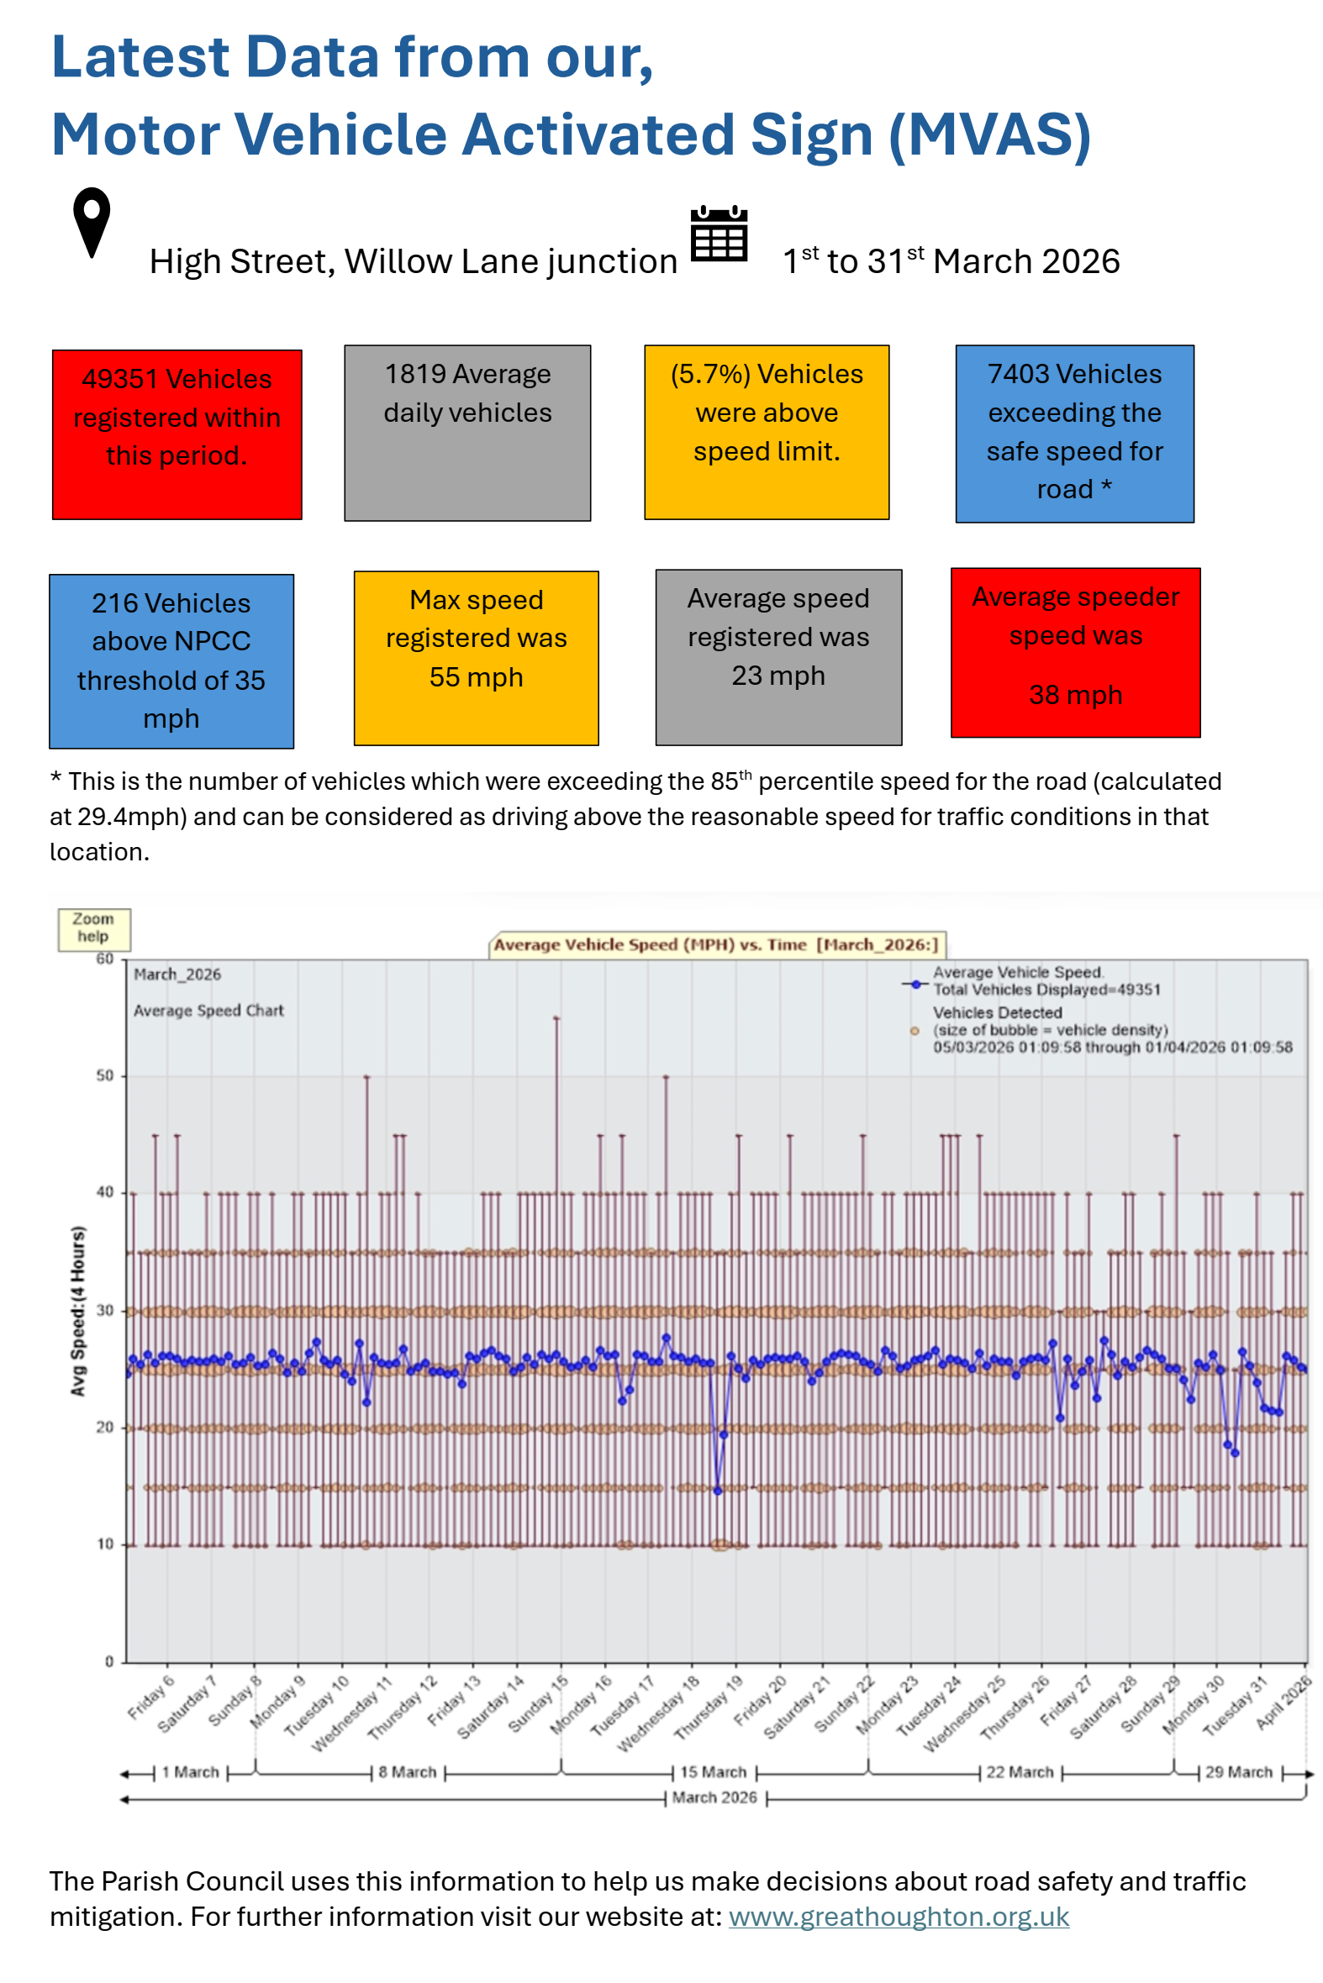

Appendix D – Internal Control Report
