Great Houghton Parish Council

Chair: Clerk:

Councillor Sarah Williams Mr Mike Billingham CILCA

The Great Houghton Annual Parish Meeting
Has been convened by Great Houghton Parish Council Chair, Councillor Sarah Williams to be held at 7.00 pm on Tuesday 19 May 2026 at
Great Houghton Village Hall, Leys Lane, NN4 0AN.

All members of the parish are invited to attend.
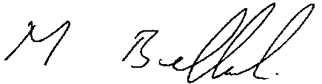

.
Mike Billingham Clerk Dated 8 May 2025

The business to be transacted at the meeting is as follows:

- Appointment of the Minutes Clerk – Mike Billingham Parish Clerk

- Apologies

- Approval of the minutes of the meeting held on the 29 May 2025.

- Chairman’s report – Cllr Sarah Williams

- To receive the reports from following organisations:
- WNC Ward Councillors
- Police
- GHPFA
- Neighbourhood Watch
- Community Speed Watch
- Parish News
- Pocket Park
- Short Mat Bowls
- WI
- Church

- Questions from the floor

- Chairman’s closing remarks

