A WARM
WELCOME
TO THE
PARISH
OF
GREAT HOUGHTON

On behalf of the Parish Council, may we welcome you to the village of Great Houghton.
We are most pleased that you have chosen to set up home in the village and hope that you find that it meets your expectations as a quiet, peaceful, country residence and lifestyle.

We are sure that you will have done your research before deciding to move in, and therefore it is most unlikely that you have chosen this village for its facilities, as there are no schools in the village, no shops, banks, libraries, or medical surgeries!

What we do have to offer however, is the services and activities from the Church of St Mary, and two fine traditional public houses, the Old Cherry Tree, and The White Hart, offering excellent meals, an excellent take-away service, as well as the occasional outdoor musical events.

We also have an excellent community playing field and village hall, managed by Great Houghton Playing Field Association. A committed number of volunteers, providing facilities for our local cricket club, football teams, and tennis club. A play area for the younger children as well as free outdoor sporting and fitness equipment for everyone to use. The village hall caters for regular group activities such as, indoor bowls, dancing, Pilates, fitness, as well as our active WI meetings. Its large meeting room, equipped kitchen and licenced bar, makes it an ideal venue to hire for private functions.

In addition to all this you can enjoy the excellent network of footpaths and cycleways that enable residents to simply step out of their front door and explore the excellent countryside that surrounds the village, as well as connecting you to the Town, local employment areas and other villages.

Finding out about all our local services and facilities, is just a ‘click’ away, by accessing our www.greathoughton-pc.gov.uk website, where you will find a wealth of information:

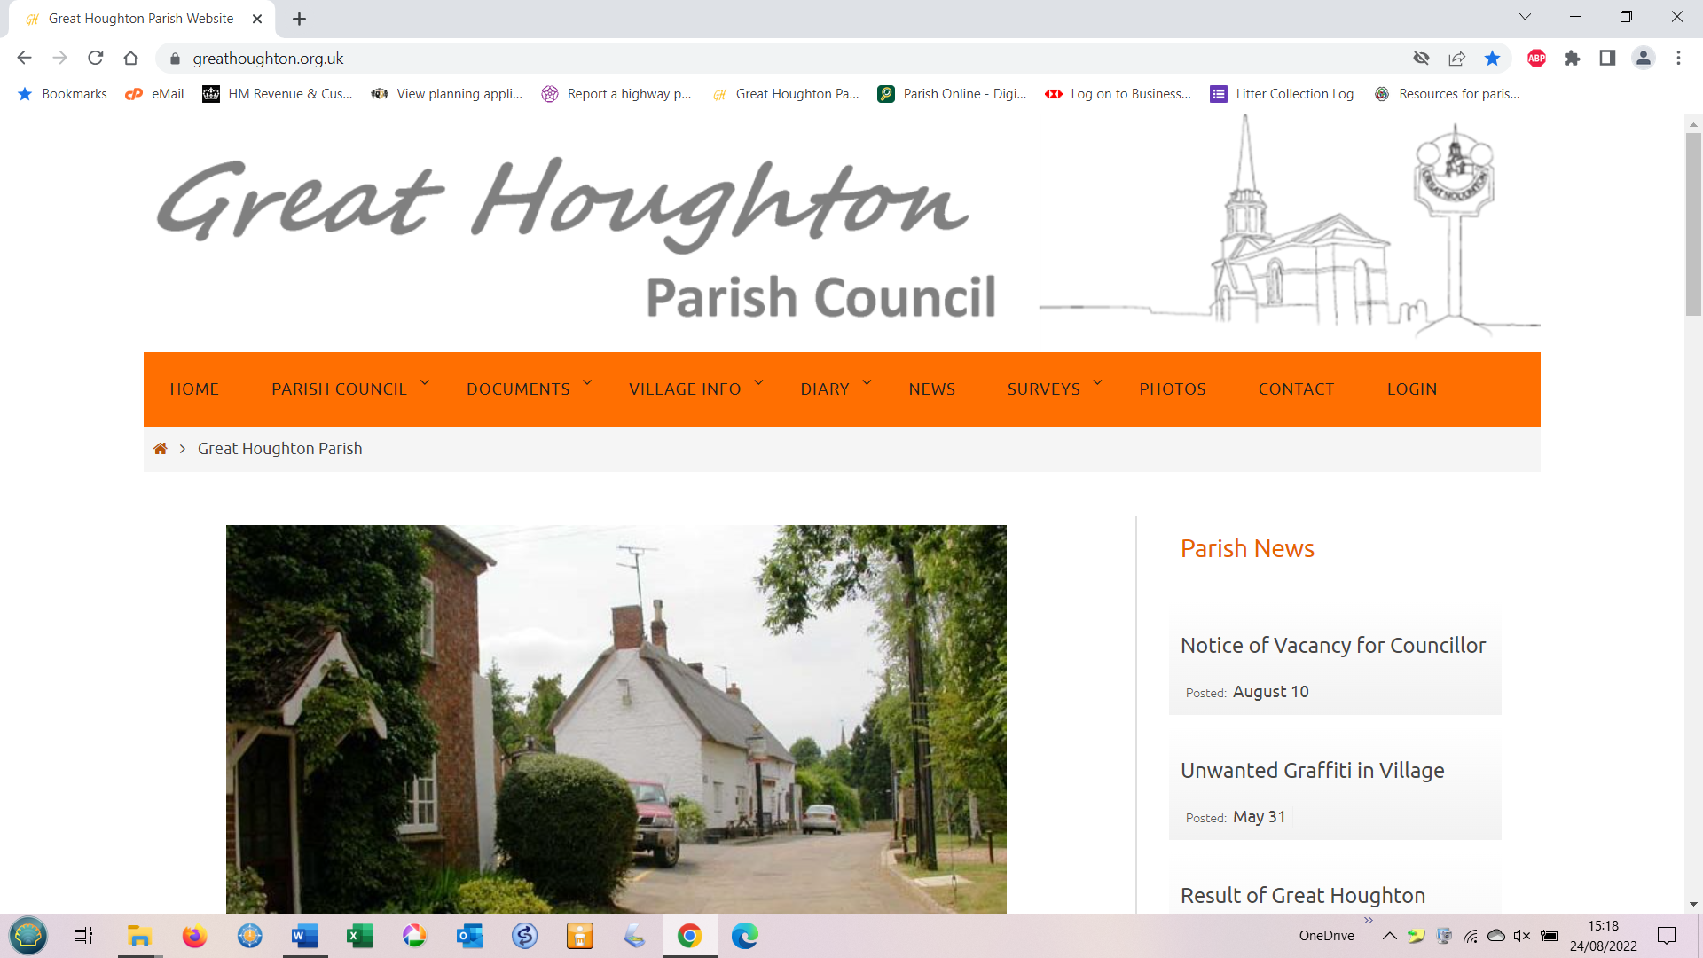

Click on each of tabs on the red bar (except login) and it will take you to relevant information, about the village, the council, activities, services and the latest notices or tweets. If you can’t find what you want simply click on and complete the contact form and we will respond with the information.

But don’t worry if you are ‘not connected’ or prefer not to use social media as we have provided several noticeboards throughout the village (see map) where you will find all sorts of information and guidance. Even better we produce and distribute, free of charge, the bi-monthly magazine ‘Parish News’ which is hand delivered to every household with all the latest news and updates.
When things go wrong, it will most likely be that it is not a matter that the Parish Council is responsible for directly and cannot therefore resolve immediately. It will therefore need to be reported to the appropriate authority or agency depending on the problem.
The principal authority for most of the village infrastructure is West Northamptonshire Council, the single unitary council covering the areas of Northampton, Daventry and South Northamptonshire. Problems should be reported directly at https://www.westnorthants.gov.uk/ or by telephone: 0300 126 7000

If the problem relates to the roads, trees or hedges, footpaths etc. then you are best to report it at https://fixmystreet.northamptonshire.gov.uk/ or at https://www.westnorthants.gov.uk/roads-and-paths/report-potholes-or-highway-problem When you will be given a reference number and provided with emailed updates on work progress.

Faults with streetlighting should be reported at https://northamptonshire-self.achieveservice.com/service/Report_a_fault_with_a_streetlight You will need to note the reference number of the particular lamp.

Water Leaks should be reported at https://www.anglianwater.co.uk/services/water-supply/leakage/report-a-leak/ or telephone 0800 771 881.

To report an incident of crime, phone 999 in an emergency. For non-urgent matters phone 101 or go to https://www.northants.police.uk/ro/report/

Anti-Social Incidents can be reported to the Neighbourhood Warden by email at neighbourhoodwardens@northampton.gov.uk or telephone WNC on 0300 126 7000

If, however, you cannot report the matter or having difficulties, the Parish Council will gladly assist on your behalf
Getting out and about from the village. Other than walking, or taking the car, this can be achieved by way of the route 41 bus service that runs between Northampton and Bedford usually every 1.5 hours, calling at the relevant bus stop on either side of the A428 Bedford Road at the bottom of the High Street

In addition, we jointly support, along with other parish councils, a minibus service ‘The Village Hopper’ that runs between Northampton and Wollaston and comes up into the village, stopping at the White Hart in the High Street. This normally provides two services in the morning and two in the afternoon.

Bus-passes are recognised on both of these services.

For those who may have mobility issues or special needs, the parish council also supports community transport schemes. These being ‘Northampton Volunteer Car Scheme’ and the former Nene Valley Help Scheme which hopefully is being relaunched through Denton surgery. These provide door-to door transport to medical and well-being appointments.

Further detailed information on all these transport services can be found on our website, in the Parish News or on our noticeboards.



Parish Council meetings take place every third Tuesday of each month from 7.30pm at the village hall and are open to public attendance. We would be delighted to welcome you to any future meeting and to address any questions you may have.
Please feel free to contact the parish clerk or your area councillor for further information.

Parish Councillor |  | Contacts | Area of Responsibility
Sarah Williams  Chair, PAG, NPSG, CSWG | 07787100242  sarah.williams@greathoughton-pc.gov.uk |  | Dobson Close, Atterbury  Way,
Guy Glennon  Councillor | 07792593995  guy.glennon@greathoughton-pc.gov.uk |  | Cherry Tree Lane, Willow Lane, Willow Crescent,
Rosemary Shaw  PAG, DSAG, CG | 01604 762579  rosemary.shaw@greathoughton-pc.gov.uk |  | Little Lane, Willow Lane (to Bridge), The Cross
Keith Barker  CSWG, FPW | 07419834758  Keith.barker@greathoughton-pc.gov.uk |  | The High Street
Julie Havard  ADAG | 07980 354432  Julie.havard@greathoughton-pc.gov.uk |  | Upper High Street, The Green, Leys Lane
Rachel Hawkins  CAN | 07770 425789  Rachel.hawkins@greathoughton-pc.gov.uk |  | Glebe Lane, Rectory Close, Paget Close
Mike Barham  GHPFA, NPSG, PLR, WCSWG, AMG | 01604 760758  mike.barham@greathoughton-pc.gov.uk |  | Lime Farm Way, Keats Close, Wymersley Close
Mike Billingham  Parish Clerk  Responsible Financial Officer | 07936 187566  clerk@greathoughton-pc.gov.uk |  | Clerk to the Council
PAG = Planning Advisory Group – DSAG = Design Statement Advisory Group – ICM = Internal Control Monitor NPSG = Neighbourhood Plan Steering Group – PLR = Police Liaison Representative - FPW = Footpath Warden GHPFA = Great Houghton Playing Field Association – CSWG = Community Speed Watch Group – AMG = Asset Mapping Group – CG = Community Group - CAN

West Northampton Unitary Council
Stephen Clarke 01604 859031 stephen.clarke@westnorthants.gov.uk

MP Mike Reader mike.reader.mp@parliament.uk
Local Police
PCSO. Paul Hurst 07557778096
Paul.Hurst@northants.police.uk
PCSO. Becky Evans. 07976 021 135.
neighbourhoodteamnorthampton@northants.pnn.police.uk

Neighbourhood Angela McNeil neighbourhoodwardens@northampton.gov.uk
Wardens Elizabeth Newbery neighbourhoodwardens@northampton.gov.uk



